Photocrystallography

Dominik Schaniel

Université de Lorraine, CNRS, CRM2, 54000 Nancy, France

dominik.schaniel@univ-lorraine.fr

The research domain of photocrystallography will be presented on the example of photoswitchable materials, in particular for the study of the structure and properties of photoinduced linkage isomers.

After a short introduction into photocrystallography and photoswitchable materials, the focus of the talk will be the study of small molecule photoswitches. It will be illustrated how a combination of several different spectroscopic and diffraction techniques, covering all time scales from femtoseconds to hours, can be used to explore the mechanism of nitrosyl linkage photoisomerization.

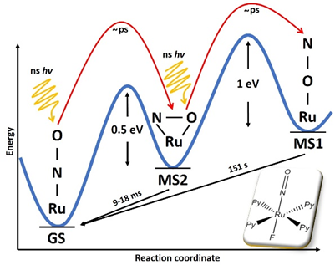

Illustration: Mechanism of generation of photoinduced linkage isomers in a ruthenium nitrosyl compound. (A. Mikhailov et al., Chem. Eur. J 2019, 25, 7569)